
CALORIE TRACKER
-Denis Timofte


Analysis
Problem identification and stakeholders
Many people, varying in age, struggle with the increasing complexity of tracking what we eat, making sure it is healthy or even something we should be eating to achieve our goals. Lots of foods are promoted using very misleading information, such as protein bars marketed as healthy alternatives although having similar sugar contents to candy bars, not being accounted for weight loss requirements, and the protein powders claiming "complete amino acid profiles" when most people already get sufficient amino acids from regular food.
There is also the issue of vegan/vegetarian diets which makes meeting your macro nutrients much harder, as many of the main sources of other nutrients lie in meat, being difficult to find appropriate meal planning. I am aiming to make my calorie tracker to give a well-rounded suggestions tab depending on different cuisines the user is interested in and a balance of the macro nutrients which you must eat to keep healthy. People also have certain dietary requirements which can relate to any allergies or health issues which require specific diets, where I am to incorporate a system that gives warnings for any foods that are being logged that may not fit your dietary requirements.
I will also have it so that the activity multiplier, which is used to calculate your basal metabolic rate, an important part of my project where I aim to make it as accurate as possible, where I will regularly make reminders to choose their activity level for the day in order to most accurately depict the amount of calories per day, to keep the calorie tracking process healthy, as a safe measure for the user to know how many calories are to be consumed.
I will cater my calorie tracker towards my client Aayan Saqib, who is of age to use my calorie tracker, and I am able to use any formulas to calculate his diet. He had tried calorie tracking, however he found that they did not meet his need for accuracies and did not see any results, even though he had been quite active, where I aim to incorporate my calorie tracker into his daily life by catering to the inaccuracies and inconveniences which he may have found using other trackers.
My calorie tracker will be useful for a wide range of users, from new users to regular users of calorie counters, which requires a simplistic approach that also offers all the necessary features that a regular user may need or find useful. My design should be intuitive and easy to navigate with all the important information stored in the dashboard/ home page of my calorie counter.
Justification of Computational Methods:
Computers can store relational databases about the client using my tracker, allowing for the creation, deletion or modification of data using SQL commands, therefore all the information about the foods logged are easily available and easy to change existing details such as weight or personal details. Also allows easy access for an admin to login and view all the user data in case they need contact information or other relevant information. Computers are required for storing the calorific values of foods in libraries with easy access, having all the calorific information ready and easy to import instead of searching for each food individually.
Thinking abstractly:
I will only ask for necessary information required to the calorie tracking to simplify the account creation and login process, where users will only have to enter a unique email and password for login. The account creation will ask for the current and target weight, with the average amount of exercise per week specifying intensity and time, which can all be changed after the account creation.
Thinking procedurally and problem decomposition:
I will use problem decomposition to segment my program into multiple different parts, such as having a landing page, login system, dashboards which usefully display information and the tracking menus which must record data. Each of these segments will all have different interfaces and layouts depending on the functionality of the segment, where each of these will have a front end, of which the user sees, and a back end, used to store any code or database with information about the user which they do not see. The structure of the application must be logical, making debugging and coding easier.
Thinking ahead:
During designing my program, I will use flowcharts and diagrams to visualize the subroutines and algorithms that I might implement, making the programming less time-consuming and reduce the probability of making an error, due to the logical processes being laid out for me to follow.

Thinking logically:
The design and construction of the project need to be developed in a logical manner, where the front-end of the program needs to be developed first so that it can accept inputs required for the back-end processes, as you cannot successfully test your back end without its completion. The order of development must also consider the order of which the user would access the tracker, where for example they would first login and then navigate the rest of the tracker to check their progress and navigate the logging menus. The structure of my code must need to be in a logical order such that the order of my classes or functions must be to use features of OOP such as inheritance. Testing will also need to be performed logically, having to use many test cases and different types of data at each stage, especially when data is written to my database.
Thinking Concurrently:
Certain parts of my application can be completed simultaneously, where for example in my login system, it will begin validating my user input, while concurrently checking the user input against values stored in the database, whilst also loading all the front-end elements of the homepage.

Research:
Looking at existing solutions
To further understand what features I should include in my website, I will research existing solutions in popular apps or websites so that I can incorporate the best features from each competitor, making my website as convenient to the user as possible.
App 1: MyFitnessPal
Worlds most popular fitness tracker, featuring one the largest food databases with over 19-20 million foods.

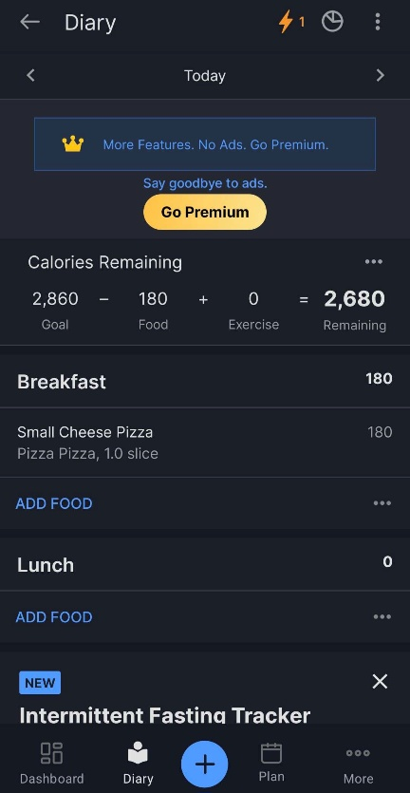

I like/ Might include | I don’t like / It doesn’t have
Simplistic design | Premium features behind paywall
Streak icon | Although simplistic, quite bland
Summation bar for calories remaining | No notes taking section
Healthy habits section | Advertisements
Different weight loss speeds
Very large food database

App 2: Lose It!
Calorie counter and weight loss app which generates personalised daily calorie budgets based on weight, activity levels and goals.

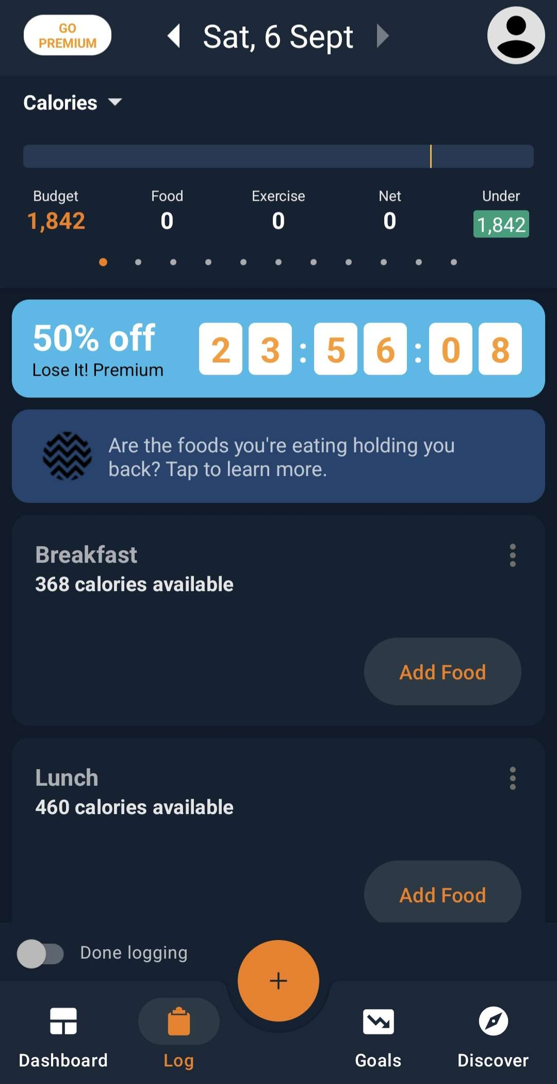
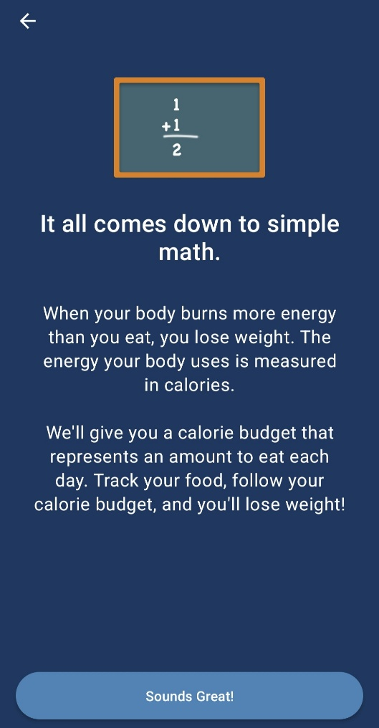

I like/ Might include | I don’t like / it doesn’t have
Short introduction to calorie tracking | High days
Smart cameras | Survey with questions that seemingly do not relate
Barcode scanning | Premium plans which are paid
Weight loss plans | Bright and distracting sale sign
Personalised calorie budgets | No graphs to track exercise done

App 3: MyNetDiary
Calorie tracker app to manage nutrition and fitness goals, is praised for being simpler and faster than competitors.
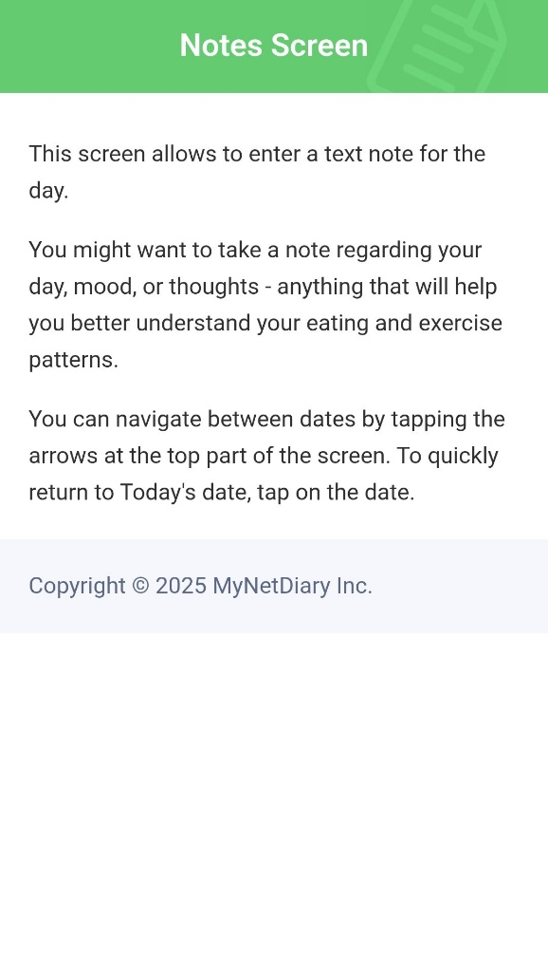
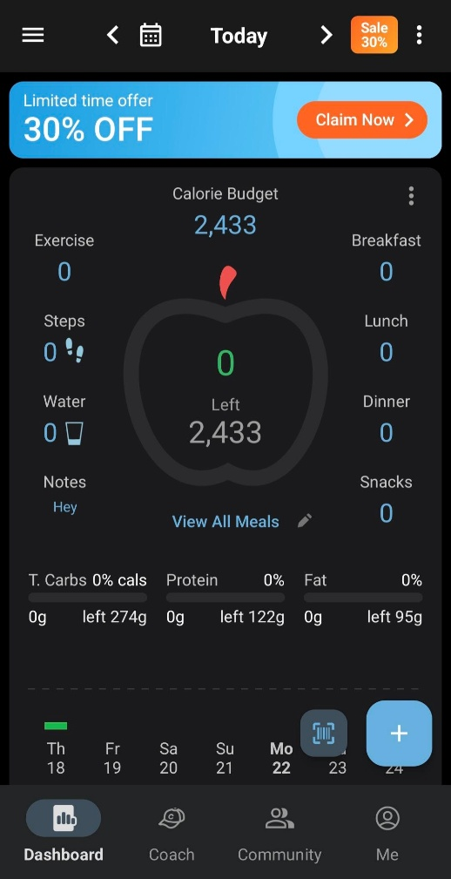
Notes tab

I like / might include | I don’t like / it doesn’t have
Visual progress bar | Premium plans
Notes tab | Distracting sale sign
All important information viewable from same place on dashboard | Virtual coach
Food gradings | Must pay for charts and macronutrient compositions.
Community section
Simple interface
Barcode scanner

App 4: Nutracheck
Calorie tracker with fully verified food database, tracking key nutrients and calories from major UK supermarkets and restaurants.
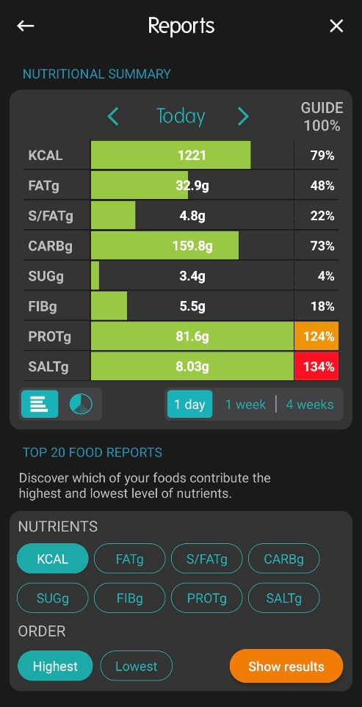
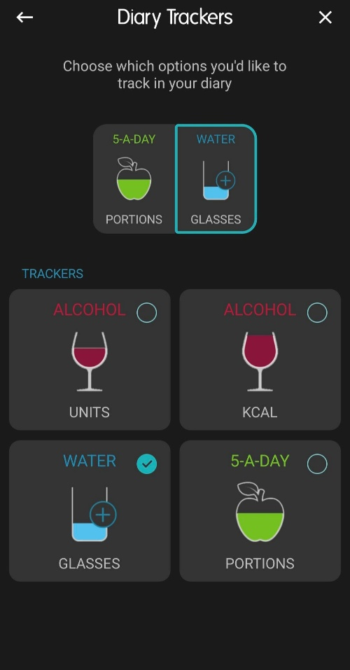

I like / might include | I don’t like / It doesn’t have
Nutritional summaries | Quite complicated
Diary trackers | Lite version restricts you to only 5 food entries- paid required
Many progress trackers for measurements such as chest, waist etc | Slow barcode scanner
Verified databases | Missing certain foods
Realistic serving sizes. Eg instead of 25g or 100g, gives per quarter/slice. Removes manual calculations.

Summary:
By looking at existing solutions, I sorted through any design aspects or features that I desire to integrate into my project, where I had made the table below with the inspiration I took and what I will add to my tracker from each application.
MyFitnessPal: | Lose It!: | MyNetDiary: | Nutracheck:
I would like to incorporate the use of the streak symbol to show the number of days with calories logged.  Show the calories remaining using a summation equation.  Healthy habits section giving common advice. | Add a short tutorial on how to track calories  Implement a barcode scanner feature working on store bought products  Smart cameras capable of scanning images of food to give result of calories. | Add an icon for the progress bar  Add a notes tab for writing messages to future self.  Food gradings based off portion size and its contents. | Use of graphs to represent nutritional summaries, using intuitive colours such as red, green and orange for warnings.  Additional diary trackers which are visual reminders for any other goals you may have.

Client interview
To help with finding his exact needs and problems, I had prepared an interview with my client Aayan, who is currently in Y2 and is 18 years old, who had not seen any progress from using other calorie trackers, where I then interviewed a personal trainer from my local gym named Jeremy, where Jeremy could use this application as a recommendation for his clients.
I have labelled which questions I asked Aayan versus the questions I had asked Jeremy.

- Question(to Aayan): “What type of interface appeals to you?”

Answer: None
Answer: “I want to see an interface where all the important information is separated in sections, with clear instructions and simple buttons to make the interface less overwhelming, where I would like for my calorie count to be the first thing I see when I open the app. I also really like the streak that I get when I use MyFitnessPal, as it’s a nice reminder of the dedication I’m putting in.”

- Question(to Aayan): “What calorie trackers have you used before?”

Answer: “ In general, I had only used two different calorie trackers, being MyNetDiary and MyFitnessPal, where I liked the interface for MyNetDiary a lot more, feeling a lot easier to use subjectively, however it didn’t have the same charm of the streaks, which are a good way for me to form habits such as learning languages using Duolingo or talking with friends in Snapchat, forming streaks.”

- Question(to Aayan): “Are there any specific features you would like in the calorie tracker?”

Answer: “I would really like to see a graph that shows both my calorie progress and exercise progress, seeing how I could spot any eating patterns throughout the month, and giving me insight into what I should do more of, where sometimes I do not know which changes I personally have to make that are specific to my situation. ”

- Question(to Aayan): “What encourages you to count calories?”

Answer: “ I get very encouraged when I see all the health benefits and potential of these tools, where I initially was very keen on losing weight to get into an ideal range, and calorie tracking was one of the first options presented to me.”

- Question(to Aayan): “What type of information would you like the tracker to store about you?”

Answer: “I would want the tracker to store all the foods and nutritional information I entered, alongside the weight and exercise so that it can form graphs later on with such information, it would also be quite useful if they stored background colour or other settings such as units that I prefer.”

- Question(to Aayan): “What type of graphs would you like implemented?”

Answer: “ I would like bar charts or a line graph for all my nutritional information, weight progress and exercise, where I could then track it for different time periods in different sections.”

- Question(to Jeremy): “What features would you like to see as a personal trainer?”

Answer: “ I would like to see help information describing what each metric in the nutrient information actually means, as many of my clients usually do not fully understand what each nutrient does and its role in the body.”
Analysis of responses:
Q | Response: | Analysis:
1 | “I want to see an interface where all the important information is separated in sections, with clear instructions and simple buttons to make the interface less overwhelming, where I would like for my calorie count to be the first thing I see when I open the app. I also really like the streak that I get when I use MyFitnessPal, as it’s a nice reminder of the dedication I’m putting in.” | The interface should be clear and bright with separation of important information inside different tabs or sections of the program, where separating this information leads to a less cluttered screen, where the home page would have the streak icon and the calories remaining and macro nutrients.

Q | Response: | Analysis:
2 | “ In general, I had only used two different calorie trackers, being MyNetDiary and MyFitnessPal, where I liked the interface for MyNetDiary a lot more, feeling a lot easier to use subjectively, however it didn’t have the same charm of the streaks, which are a good way for me to form habits such as learning languages using Duolingo or talking with friends in Snapchat, forming streaks.” | Make sure that my interfaces are both easy and attractive to use, while making sure to include the streaks feature which seems to be a defining feature against my competitors.
3 | “I would really like to see a graph that shows both my calorie progress and exercise progress, seeing how I could spot any eating patterns throughout the month, and giving me insight into what I should do more of, where sometimes I do not know which changes I personally have to make that are specific to my situation. ” | Use graphs to show progress depending on different statistics such as exercise, weight, calories consumed or the nutrients summary for each food, being useful for the user to see and track their progress visually.
4 | “ I get very encouraged when I see all the health benefits and potential of these tools, where I initially was very keen on losing weight to get into an ideal range, and calorie tracking was one of the first options presented to me.” | Make it obvious to the user all the features that are available on the website, while also having help icons to describe the use and benefits of each one.
5 | “I would want the tracker to store all the foods and nutritional information I entered, alongside the weight and exercise so that it can form graphs later on with such information, it would also be quite useful if they stored background colour or other settings such as units that I prefer.” | I am going to create relational databases which can store important data specific for each user, where I could then use the data for graphing or other useful features which require previous data, also making my application more convenient to use.
6 | “ I would like bar charts or a line graph for all my nutritional information, weight progress and exercise, where I could then track it for different time periods in different sections.” | Create different graphs which the user can scroll through, making it visually appealing and simple to understand, giving customizable options such as the time period it is averaged over.
7 | “ I would like to see help information describing what each metric in the nutrient information actually means, as many of my clients usually do not fully understand what each nutrient does and its role in the body.” | When designing the help icons, I will create one for each nutrient, making it as simple to understand and including analogies which can help the learning of each function, this is so that it aids in the meal planning of the user depending on their goals.

Stakeholder Survey:
I will also carry out a survey for a group of students from my school to see what features they would like in the program:

Question 1:
Have you ever used a calorie tracker before?
- A) Yes
- B) No

Question 2:
What features would you like the calorie tracker to have?
- A) Barcode Scanner
- B) Graphs
- C) Notes (diary)
- D) Streaks
- E) Image as progress bar

Question 3:
Do you prefer to view your results graphically rather than numerically?
- A) Yes
- B) No
- C) Both
- D) Indifferent

Question 4:
How important is customization for your experience?
- A) Very crucial
- B) Somewhat Crucial
- C) Neutral
- D) Not crucial

Question 5:
How often do you change your email or create/use a new one?
- A) Never
- B) Occasionally
- C) Often
- D) Very often

Question 6:
Would you find it useful for all your results to be saved in an account?
- A) Yes
- B) No
- C) Indifferent

Question 7:
Would you find it better to use the tracker without your progress saving?
- A) Yes
- B) No
- C) Indifferent

Question 1:
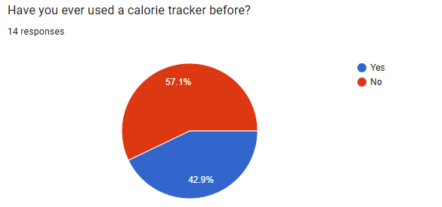

This statistic tells me that most of the responses I am getting are coming from people who never used calorie trackers, which can include features that would encourage people to start trying calorie tracking.

Question 2:
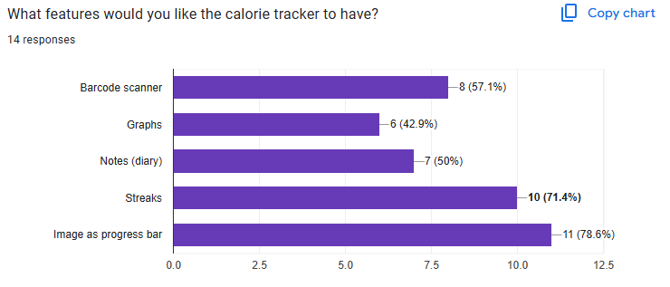
The answers gave me an insight of how important streaks and progress bars are compared to the other features

Question 3:
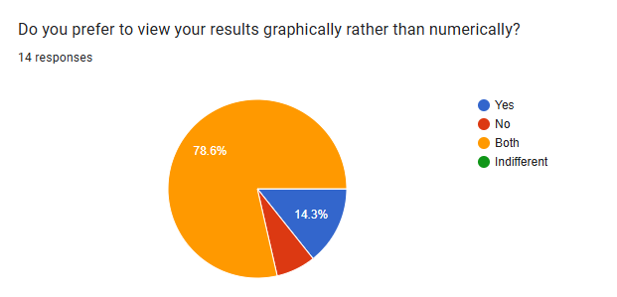
This highlights the importance of graphs even though it was the least voted feature, as many people much rather view their progress numerically as well as graphically, where even if it is not a highly voted options, it is still a vital feature that must be implemented.

Question 4:
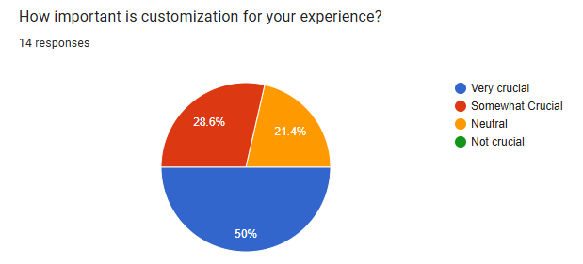
Majority of votes found that customization was somewhat or very crucial, as people may like a darker theme or different colour palettes.
Question 5:
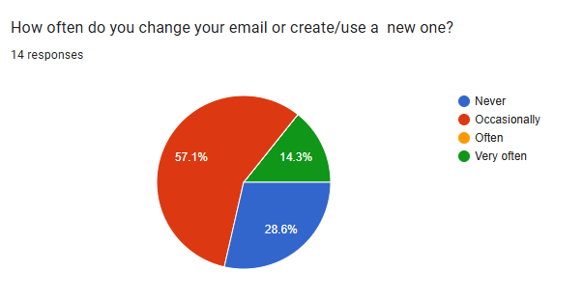
This tells me that there are a small amount of people who change their emails frequently, which could be difficult for them to track their progress as my login would require an email and password.

Question 6:
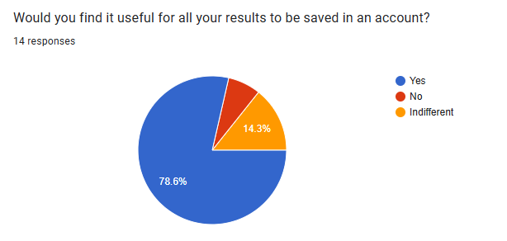
This proves the need for a database to store all necessary information, as people find it important to have their progress saved in an accessible account.
Question 7:
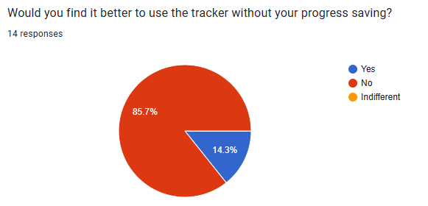
Only a small minority prefer their progress not saving, as they may not be interested in using the app for a way of looking back on previous habits or patterns.

Features of the Proposed Solution:

After researching existing solutions, interviewing my client, and my stakeholder survey
I had determined the features and requirements of my program.

- My program will contain a home page which will have the highly requested streaks icon, where they will have an icon for the progress bar tracking the calories remaining and consumed, with the main macro nutrients of fats, carbs and proteins with their separate progress bars and a notes tab which acts as a small diary. The app will be sectioned off into different graphs that you can access depending on your need and have the option for additional diaries. There will also be an account creation with a short survey required for any calculations or important information needed.

- The login screen will use Pythons Tkinter library for the front end, facilitating user login with storage of user information in a SQL database, being accessed using the SQLite library, where it will store the user information such as their height, weight, goals, and all other metrics which are required for graphing or calculations. The login screen will allow users to create new accounts and customise their interface. When dealing with graphs, I will use libraries such as matplotlib.

# | Feature | Description | Evidence
1 | Signup system | Allow users to fill out their login details and a quick survey which will be validated and added to the database, stored for future calculations. Tutorial on calorie counting in the signup system | App 2- Lose It!: Offers a quick tutorial during the login screen which also asks survey questions used for calculations.  Stakeholder Survey- Question 6,7
2 | Login System | Allows users who have existing accounts to login and gain access to their account and progress by entering email and password.  - | App 2- Lose It!: Allows users to log into their accounts through email and password.  Stakeholder Survey- Question 6
3 | Logging System | Allows users to log food, exercise and weight through drop down menus and input boxes. | App 1- MyFitnessPal: Allows user to log their breakfast, lunch and dinner alongside the weight and exercise.
# | Feature | Description | Evidence
4 | Streaks | Gives a record for how many days calories have been logged, tracking the time | App 1- MyFitnessPal: Has a streak icon at the top of the screen which shows the number of days with calories logged.  Stakeholder Survey- Question 2  Client Interview- Question 2
5 | Graphing of results | Gives a graph representing progress given over a select amount of time using logged data. | App 4- Nutracheck: Has a nutritional summary graph showing all of the nutrients of the foods eaten. Also has graphs showing weight recorded.  Stakeholder Survey- Question 3  Client Interview- Question 3,6
6 | Guide to calorie tracking. | Help bubbles that can explain nutritional values or short guides that explain the calorie tracking guide. | App 2- Lose It!: Has a short introduction to how calorie tracking works during the middle of the survey  Stakeholder Survey- Question 1  Client Interview- Question 7
7 | Notes/ Diary | Notes tab that allows the user to write information that would be important when looking back on that date. | App 3- MyNetDiary: Has a small tab which you can write your notes in, you can revisit previous notes through a calendar feature  Stakeholder Survey- Question 2
8 | Settings | A settings menu which allows for customization of the application, being able to select different themes or modes. | App 1-MyFitnessPal: Has an option for light and dark mode.  Stakeholder survey: Question 4
9 | Barcode scanner | A barcode scanner which can read and give nutritional summaries of scannable food items. | App 2 and 3- Lose It! And MyNetDiary:  Barcode scanners available when going to logging menus.
10 | Smart Camera | Camera that allows you to take photo of your food, giving its nutritional summary | App 2- Lose It!: Smart camera available for free version
11 | Healthy habits | Messages encouraging healthier habits and lifestyles. | App 1- MyFitnessPal: Short messages on dashboard that gives healthy advice related to exercise and dieting.
12 | Food grading | Foods are given grades depending on their contents and portion size in which they are consumed. | App 3- MyNetDiary: Each food grade is showed when trying to log it.

Hardware and software requirements:
The minimum hardware and software requirements for the user are shown below:
- OS: Windows 7 or higher, MacOs or higher
- CPU: 2 GHz or faster x86 or x64 processor
- RAM: 1GB or higher
- Peripherals- Keyboard, mouse and monitor.
- Python 3.7 or higher

The program will require Python 3.7 or higher to be installed on the operating system. Since python is a high-level language, it offers abstraction from assembly and machine code, making it much easier to code large program through simplifying. High level code translation demands more processing power, where having sufficient hardware minimises any performance issues or delays, where using a low level language can introduce high levels of complexity when dealing with memory management, as it does not support these features. Compatibility is limited to desktops and laptops with the required operating system, where interactions with the GUI only requires a keyboard and mouse to navigate and type notes for any answers.
The software requirements for the developers listed below:
- IDE- Visual Studio Code (Python inbuilt)
- Databases- DB browser for SQLite

The Visual Studio code IDE offers lots of optimal software for program development, with features such as colour coding, auto completion and line numbering. Also allows for direct trouble shooting code using variable tracking and breakpoints, with crash dumps storing the value of the variable when the program crashes. Since my programs backend relies on an SQLite database, which allows for clear and organized database viewing , which has extensions for DB browsers which enables the viewing of all the SQL code for my tables and adding changes to SQL, through adding new tables, fields and assigning primary keys.

Limitations of the solution:
- The list of foods that I will be able to offer will be the restricted to the limits of the APIs, as there is an issue of file size and taking longer to develop by including too many niche food options, especially under the time constraint provided, which could be included in the future if required. I should also reduce the list to more general foods as it can raise the issue of people being overwhelmed on calorific values are correct for the ones they are eating.
- The primary constraint is the time period, which will cause for the simplification of certain features, where my main focus is to incorporate essential features that a calorie tracker may need, for example the logging menus and then logging all options.
- I will use simplifications on the interface, where I will exclude any animations or sound effects as they are not essential to the users needs for logging their calories, where the abstraction of these features will also reduce file size, making it much more accessible and reducing development and testing time which can be reserved for core features.
- The programs compatibility is limited to Desktop computers and laptops, where accommodating other devices or operating systems like mobiles would require additional framework, which also means extra testing for each device, and extra maintenance for each device, being implemented through all platforms.
- Many of the libraries or API’s I might use could get updated or changed, meaning that I would have to edit my code to accommodate the current libraries, making sure that it is up to date as part of my maintenance. I will leave the interface the same until I decide that it requires changing.
- The formatting of my program will not be very easy to distribute, since I am running this app on Tkinter, it must be compiled each time it is run, where this will only work if the user has an appropriate version of python installed. When developing the tracker, this is fine as I only require it on my device, but when distributing the program I will have to compile all relevant files into one executable file.

Requirements of the System:
Signup/Login:
Requirement: | Description:
Allows new user to create an account | Users must enter a valid email and password which meets requirements for security purposes, where they must enter their name, height and weight, calorie goals, and wanted background colour for personalization.
Allows users to login with their email | Users can enter their unique email and a complementary password to that email to gain access to their account of which all their progress and information is stored, being able to access and log any progress they need.
Ensure no duplicate accounts/records created | If a user enters an already existing email, it will alert the user that there is an already existing account after being search for as a record on the database, giving the option for forgotten passwords which can send an email allowing them to reset their passwords.

Home page:
Requirement: | Description:
Calorie progress bar | Users will have an image depicting the amount of calories remaining for their target goal, filling up with the more calories consumed.
Streaks | Each user will have a streak icon available on the top right of their screen, representing the amount of consecutive days with calories logged.
Macro nutrients bars | Smaller bars addressing important macronutrients showing which nutrients their diet is missing, helping in meal planning.
Simple interface | No overwhelming or overly colourful background, as it can be quite irritating or distracting when trying to use the application.
Easy to use dropdown menus | Menus used to log the food intake on each meal and exercise, being able to search for each food inside the dropdown menu.
Barcode scanner | Scannable food items can be used in configurable quantities.
Smart camera | Take pictures of food to get an AI summary of their nutritional information.
Healthy habits | Small messages giving healthy lifestyle advice.

Results / Progress page:
Requirement: | Description
Graphs | Users will have access to a section where they could see the graphs of the change in weight, calories eaten each day, exercise or nutritional summaries depending over the time period they require.
Clear representation of data | Alongside the graphs, the progress and data would be represented in a clear numerical way, paired with the graphing to give a visualisation, making it easier to monitor their progress
Calendar | Be able to view individual results based on a calendar which retrieves all the information from the given day.
Food grades | See the grade of the foods that you are eating, to realise healthier alternatives or give insight on foods which may not be as healthy as previously seen

Settings page:
Requirement | Description
Settings on home page | Users will be able to view their personal information in the settings page, which would be on the top right of the home page next to the streaks icon
Clearly display users details | User should have access to all the information the tracker has stored about them, being easily accessible in the settings page.
Allow user to edit information | Give users ability to change or edit their information when no longer up to date or accurate, including stuff like their height, weight, email, or password.

Justification of criteria:
# | Criterion | Justification
1 | Allow users to create new account | Users will need to have an account that stores all their information over a certain time period in order to be used for calculations and the purpose of logging and diary taking.  This had been made obvious to me in the stakeholder survey question 6 and 7
2 | Allows users to login with email and password | Each user should have an account where they can securely login to their account to view all their progress, where their email address will be a unique identifier for logging into their unique account with all their progress.
3 | Store users data in database | All of the users information and data should be stored in a database where all their information is stored under the unique identifier of their email.
4 | Validate the user information, showing suitable error messages when failure. | Make sure that all the inputs are reasonable to their respective fields, where all the inputs are validated before being stored in the databases, giving an error to ensure that the data stored is reliable and valid.
5 | Have a calorie progress bar | Contain a progress bar that shows the amount of calories remaining, being able to visually and numerically show the amount of food user is still allowed to eat
6 | Streaks icon top right of home page | Streak icon at the top right of the home page, being visible to the user when first entering the app, so that the user can see the amount of consecutive days logged in as a habit.
7 | Macro nutrients progress bars | Macro nutrient bars are very important for meal planning their next meal, as they may notice a lack of a certain nutrient or an excess in another, being very important for appropriate and healthy diets.
8 | Dropdown menus for calorie and exercise logging. | Dropdown menus for logging calories and exercise, where they can quickly search through a catalogue of foods, which are a requirement for being able to input foods from an already existing
9 | Notes tab for diary taking | A notes tab would be quite useful for people to take notes for looking back on the day, storing important information they may need to reflect on in the future.
10 | Barcode scanner | Gives most accurate results as you can directly use the real nutritional information, making it a much better used alternative to manually searching a food.
11 | Smart camera | Able to give a rough idea of what food you are eating, already giving a reasonable nutritional summary if you are not sure of what your food may have inside it.
12 | Healthy habits | Can give quick reminders which can help people better their lifestyles and habits or give motivation to continue pursuing these habits.
13 | Food gradings | Gives insight on how good a food might be depending on its portion size or contents which can guide people in meal planning.
14 | Show summation of calories remaining numerically. | The results should also be paired numerically, as shown by the stakeholder survey question 3, as this is quite useful for people to understand their results through numbers simultaneously with the graphs.
15 | Display different graphs of each category (weight/exercise/calories/nutrients) | Different graphs for exercise, weight, calories eaten and nutritional summaries, being quite useful as shown by stakeholder survey question 3 and client interview question 6, where many of the users will prefer having a graphical representation of their results.
16 | Calendar for retrieving past dates | A calendar would be useful for users to look back on specific food eaten and checking their notes from that date, where being able to look back on previous meals can be helpful for meal planning or reflecting on eating habits that should change.
17 | Select different time periods for which they want to view | Having different time periods available allows for people to see change ranging from a month, to a week, to any amount of days they may want, where they can have days where they may not fully follow their calorie plan, and they might want to track the calories to exclude these days.
18 | Use clear and bold text to display results, allowing user to identify/ read information more clearly | Clear and bold text allows the user to see their results more clearly, as it is the main focus of the user.
19 | Display users latest/ most updated details. | The settings page should allow the user to see all of the updated information currently stored about them, as it is one of their rights.
20 | Allow users to update their data/ information | Settings page can allow the user to change their personal information at any time, being able to update.

Design:
Introduction:
The program can be composed of multiple different parts, where all will use a Tkinter front end and a SQLite database for the back end:
- Signup page
- Login page
- Home page
- Graph viewing page
Decomposition of the program:
Component | Tkinter GUI (Front-end) | SQLite Database (Back-End)
Signup Page | Allow user to create an account if they do not have one after pressing the sign up button from the login page, which will ask all account creation questions such as email, password, weight etc, where all inputs are to be validated. | When all the inputs have been validated and sanitised, if this account does not already exist, it will create a record with a unique index (Primary Key) which will be generated for the user.
Login page | Allows user to input unique email and corresponding password to gain access to their account, going to the main page, where they will only be asked for 2 entries | Users inputs will be checked against matching and corresponding values, where the user will be granted entry if both username and password are correct specific to that account, where if no match is found an error message will be returned.
Home page | The home page will have a progress page with the calories remaining in an image progress bar, with macro nutrient bars below for meal planning, and the dropdown menus which can be used for quick search of the foods wanted. | This page will retrieve information from the users records to give the calorie goals, where they will also have the information stored about them in the settings menu. Calories will also be logged into the database through the dropdown menus.
Graphs page | Users will have a section with the graphs of the weight progression, nutrients consumed and the exercise all logged across different time periods, where this information will be presented using matplotlib with numerical data alongside. | The information for the required graph is retrieved depending on different time periods using SQL commands, where the data retrieved can be specified to anything the user wants.

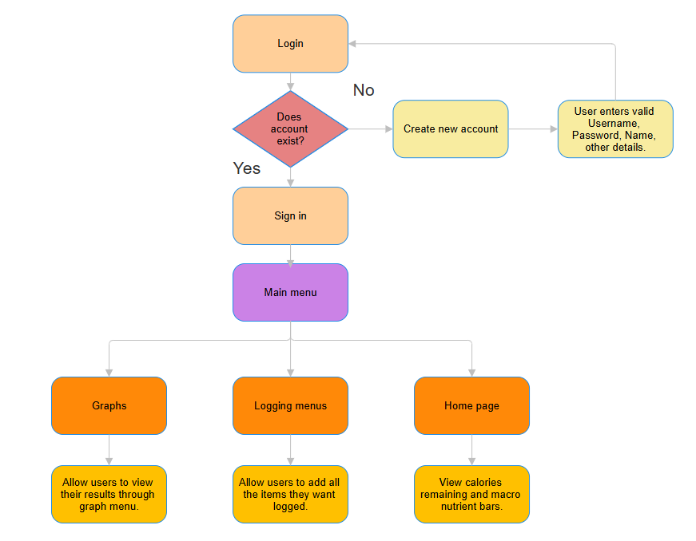
Top-down Diagram:

This flowchart shows how different sections of how the program will be constructed, and their relationship to each other, serving as a visual decomposition and abstraction of my problem, allowing me to write my code modularly depending on each section, also helping me to format the logic of the app.

Algorithm Design:
In this section, I will create pseudocode and flowcharts for each major algorithm for the diagram above, which will be more efficient as I can focus on one module at a time through problem decomposition, which makes combining these modules very easy, especially as the logical structure of my program is already set out, decreasing time to develop the program.
Signup/Login Authentication:
When user attempts to log into account, I will design an algorithm that checks that both the username and password entered are checked against the details in the database, which ensures security and preventing unauthorized access to different accounts
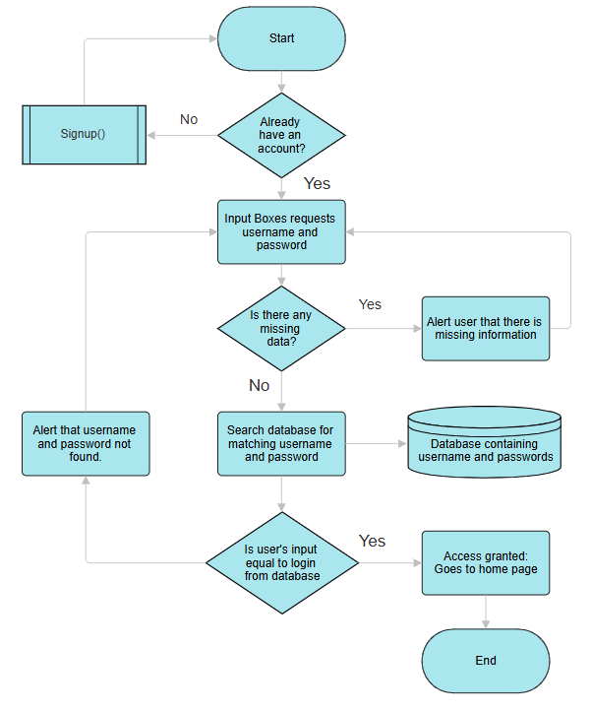
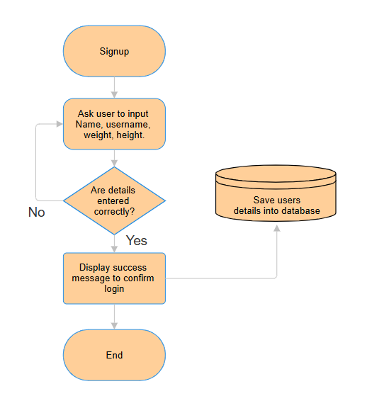
Flowchart:

Pseudocode:
FUNCTION Login:
GET username FROM user
GET password FROM user
IF username is empty OR password is empty:
SHOW message "Please enter both username and password"
ELSE:
FETCH password FROM database WHERE username equals entered username
IF password is not found AND username is not found:
SHOW message "Account not found"
ELSE IF password does not match Username:
SHOW message "Incorrect password"
ELSE:
GRANT access

FUNCTION Signup:
GET Name FROM user
GET Username FROM user
GET Password FROM user
IF Name is empty OR Username is empty OR Password is empty:
SHOW message "Please fill in all required fields"
ELSE IF Password is not sufficient:
SHOW message "Password should be at least 8 characters long"
ELSE:
ADD user details to database

Progress page:
This algorithm should allow users to track their progress by viewing their calories, nutritional information and weight in a specific period of time, critical for allowing user to identify patterns. Will need to store and load data from a database containing all information
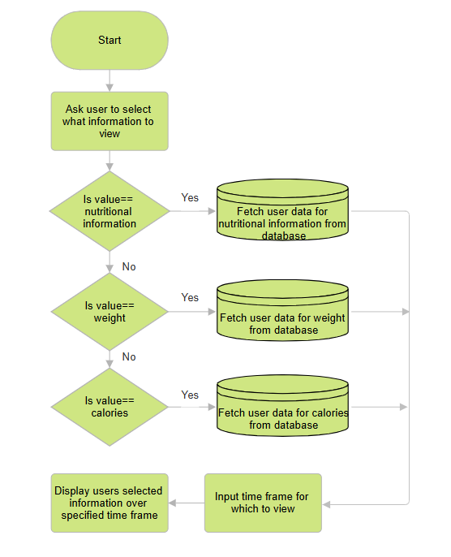

FUNCTION Stats_Page:
Display Button1 “Weight"
Display Button2 “Calories"
Display Button3 “Nutritional information"

Let user choose an option
Let user input a time frame

If the chosen button is Button1:
Display weight history graphically

Elif the chosen button is Button2:
Display calorie history graphically

Else the chosen button is Button3:
Display recent nutritional information in suitable table

Settings Page:
This algorithm will display the users information after log in, such as their name, password, bodyweight and height. This will allow them to view and change their information so that it can remain consistent and accurate. They should be allowed to change their information at any time and the updated information should be used to recalculate your maintenance. If a user chooses to edit but does not apply any changes, they will remain the same in the database.

Pseudocode:
FUNCTION Settings_Page:
Display User’s Name
Display User’s Email
Display User’s Password
Display User’s Weight
Display User’s Height
Response = button input "Do you want to edit your ` profile?"

If RESPONSE == True:
NEW_NAME = GET_NEW_NAME FROM user_input
Update name in database with NEW_NAME

NEW_USERNAME = GET_NEW_USERNAME FROM user_input
Update username in database with NEW_USERNAME

NEW_WEIGHT = GET_NEW_WEIGHT FROM user_input
Update username in database with NEW_WEIGHT

NEW_HEIGHT = GET_NEW_HEIGHT FROM user_input
Update username in database with NEW_HEIGHT

NEW_PASSWORD = GET_NEW_PASSWORD FROM user_input
If NEW_PASSWORD is NOT Valid:
Display "New password does not meet requirements. Try again."

Else:
Update password in database with NEW_PASSWORD
Display "Password changed successfully!"

Flowchart:

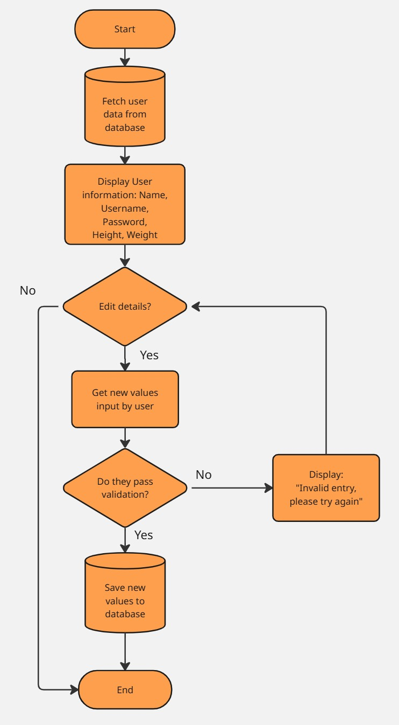

Database design: #CHANGE DATABASE TBLS TO BE ACCURATE.
The calorie tracker should need a backend database to store the users details and important information that they may need to track, being necessary for most functionality of the tracker. This will contain information like usernames and passwords which are static and cannot change, then will have separate tables for sorting dynamic items such as calories consumed and exercise, where this will be essential for creating my visual representation inside the project. Databases will be connected by one to many relationships as the user will have multiple data to store, where the primary key is User ID for which the accounts are given a unique number which indexes each user by the order of account creation. I am going to user queries to retrieve the data required and will use first normal form to get rid of redundant data and make my database clearer, more organised and efficient.

Table Name: | Description
Users | Store the login and account details from signup
Weight | Allow users to track their weights by entering new values of weight at different times, to be used for visual representation.
Exercise | Able to log exercise for current day to be used in calorie summation, to be seen in user history containing important information.
Food Eaten | Log foods from an external API database storing all the important nutritional information and calories needed for calculations and data representation.

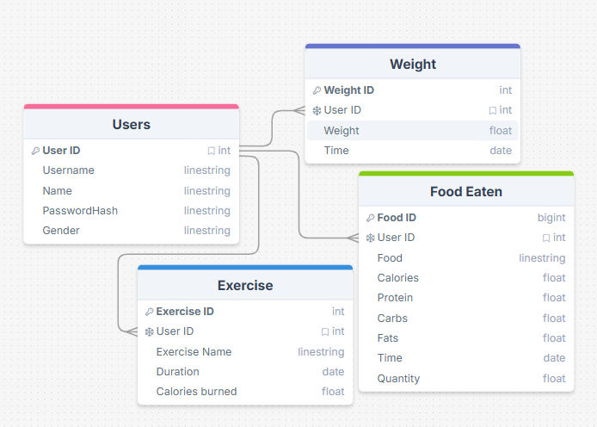
Tbl Users:
Column Name | Data Type  (SQLite) | Constraints | Description
User ID | INTEGER | PRIMARY KEY  UNIQUE | Must be unique for each user to be able to identify records and be used as a primary key to be used as foreign key in other tables.
Username | TEXT | NOT NULL | Username must be unique and belong to the user, must be present and valid
PasswordHash | TEXT | NOT NULL | Password must meet certain requirements to ensure safety, as long as being hashed to  make passwords more secure. Validation: 8 letters long, Capital letter, lowercase letter, special character.
Name | TEXT | NOT NULL | Store the users first name, used to show who the account belongs to and personalise the application.
Gender | TEXT | NOT NULL | Needed for calculations such as calorie maintenance, due to differing biologies.

Tbl Weight:
Column Name | Data Type  (SQLite) | Constraints | Description
User ID | INTEGER | FOREIGN KEY  UNIQUE | Used as a foreign key from the Users table in order to create a link between the two tables, where this must still be unique as this correlates to the user.
Weight ID | INTEGER | PRIMARY KEY  UNIQUE | Unique primary key for this table which indexes the entries for the weight, giving a chronological order for which the weight has been entered.
Weight | FLOAT | NOT NULL | Shows the value of the users weight in relation to that period in time.
Time | TEXT | NOT NULL | Store the users real name, used to show who the account belongs to and personalise the application.

Tbl Food Eaten
Column Name | Data Type  (SQLite) | Constraints | Description
User ID | INTEGER | FOREIGN KEY  UNIQUE | Used as a foreign key to relate the two tables together, must be unique as this information must be stored with a specific user.
Food ID | INTEGER | PRIMARY KEY  UNIQUE | Unique identifier for the ID of the food used, which can be taken from the food database API which I have imported, used to uniquely identify the food eaten.
Food | TEXT | NOT NULL | Unique name for the food to know where the calorific information is coming from.
Calories | FLOAT | NOT NULL | Store the calories dependent on the grams and food type eaten.
Protein | FLOAT | NOT NULL | The grams of protein content in selected food for that amount of food.
Carbs | FLOAT | NOT NULL | The grams of carbohydrate content in selected food for that amount of food.
Fats | FLOAT | NOT NULL | The grams of fat content in selected food for that amount of food.
Time | TEXT | NOT NULL | The date at which the food is eaten to be sorted into chronological order for data representation.
Quantity | FLOAT | NOT NULL | Amount of food consumed in grams

Tbl Exercise #NEED CHANGE
Column Name | Data Type  (SQLite) | Constraints | Description
User ID | INTEGER | FOREIGN KEY  UNIQUE | Used as a foreign key from the Users table in order to create a link between the two tables, where this must still be unique as this correlates to the user.
Exercise ID | INTEGER | PRIMARY KEY  UNIQUE | Unique primary key containing the id for the type of exercise, this can be related to the external API required to add these exercises.
Exercise Name | TEXT | NOT NULL | Unique name representing the type of exercise done.
Time | TEXT | NOT NULL | Stores the date for when this exercise is logged, to be seen inside history.

Screen design:
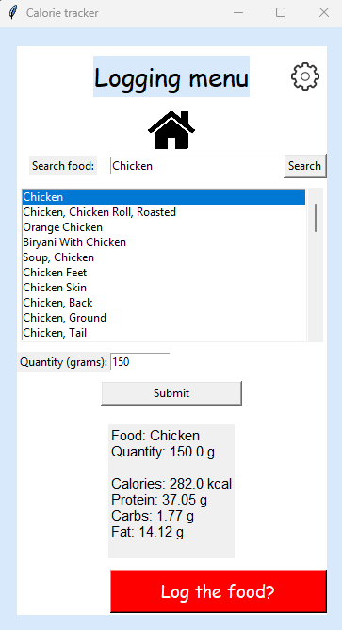
Logging menu:
Settings
Return to home page button
Search for the correct food through a library from the USDA by input search and finding on the dropdown list
Shows all the nutritional and calorific information for the selected option based on input quantity
User inputs the quantity of the food
When pressed, this will log the food in a database with correct quantity to later be used in graphing and calculations such as their calorie and nutrient intake
Chicken Breast
Chicken soup
Chicken Tail
Chicken feet
Chicken 150g
Calories: 282kcal Protein: 37.05 g Carbs: 1.77 g Fat: 14.12 g
Log food?

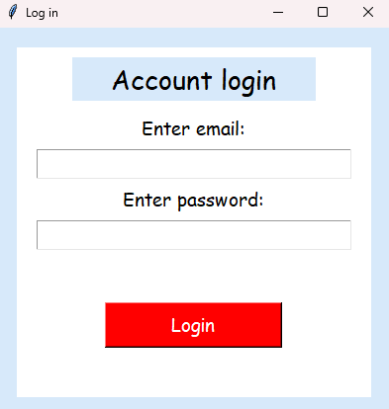
Log in:
User enters email here:
User enters corresponding password here
When login button is pressed, the algorithm will be run to check the input details against the data stored in the database, it should give a suitable response depending on success.
Sign In

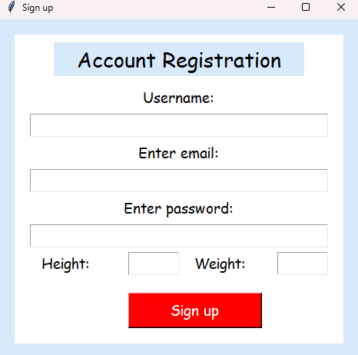
Sign up:
User enters email here:
User enters password:
Name of the user:
User inputs height and weight used for calculations to find the correct maintenance calorie budget.
Sign In

Settings:
#PUT UPDATED IMAGE

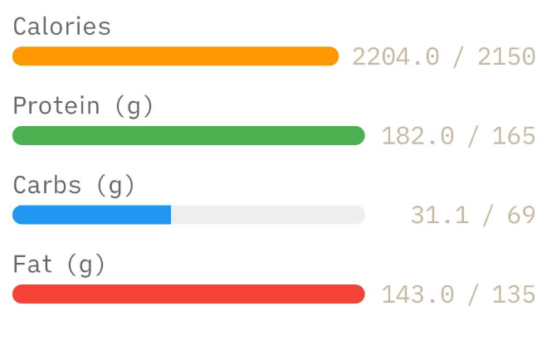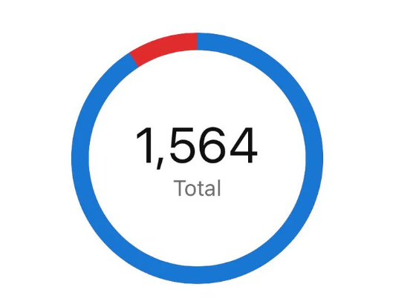

Usability features:
My client identified many features which he thinks would help improve usability of the program, where the navigation between data representation, home screen and logging menus should be integrated together and be simple, intuitive and compact, making it easy to use for all people.
Consistent colour themes and layouts are vital points for a good interface, where my style has a consistent light blue border and white background throughout all pages, with large visible buttons and bright colours to ensure the visibility and clarity of my program. The text has an appropriate font and size, being bold when necessary. For example all of my titles are written in bold to increase clarity, with big red buttons at the bottom of each of my pages to submit final changes and ensure user has a clear path to progress.
My program will have all of the buttons and features incorporated into my home screen where I will have the progress bars as the main focus of the home page, with big addition buttons next to each meal of the day also showing the calories eaten for that day. The data representation button will be at the bottom of the screen.
There should also be data validation in any text boxes where user can input values, making sure that they do not input inaccurate data or inappropriate data types, showing error messages for when they input something incorrectly. An example would be during sign up to create boundaries for the height and weight input from the user, where height must be an integer greater than 0 and lower than the tallest person alive. Same can be done for weight and other entries which require user input. Password validation is also very important to make sure users all use secure passwords to prevent brute force attacks. Usernames should also be unique, where user should receive an error message when typing an already existing username for sign up.
For most screens, an alert error message should be used to notify the user of any problems, where user must manually close meaning that they have to read the notification first. This helps as sometimes changing labels may not be very noticeable and so this would increase user experience. This message box should alert the user of exactly what they should do to proceed, giving a reason for every error message.

Justification of Usability Features:
# | Feature | Justification | Reference
1 | Titles | Clear and evident titles which stand out for the page to give a clear indication to what the page is going to be. Makes navigation easier. | Login Screen  Sign up Screen  Data representation screen  Home screen  Logging menu screen
2 | Buttons | Big, bright buttons strategically and compactly placed for data input, which promotes efficient interaction with the program. Reduces errors as it is easy and intuitive to use. | All pages
3 | Entries | Clearly labelled entry locations for the user to type in data, this gives the user added interactivity as they can type anything rather as long as appropriate rather than selecting from drop down menus, which is a lot more efficient. | Login screen  Signup screen  Data representation screen  Logging screen  Settings screen
4 | Images  /Icons | Visual cues which can help user navigation of the interface and I can use to disguise buttons by being intuitive to their functions and distinct from all other images, where this enhances accessibility. | All pages
5 | Colour  Scheme | Consistent colour scheme throughout all pages and sections which aids user in readability of the site, especially as this is changeable. This can create contrast between important material to guide the users attention to correct progression. | All pages
6 | Layout (logical) | All items are organised compactly and in a way that is intuitive to access, where the home page branches off to all different methods of the program. Content is prioritised by importance and is consistent in its organisation throughout all pages. | All pages
7 | Graphs | Multiple graphs to visually represent data, this helps users in understand interpreting the data. This will have clear labelling and scaling with colour to represent different values, for example a nutritional summary will have 3 lines for each protein, carb and fats of different colours. | Data Representation screen
8 | Alert Messages | Pop up message boxes which alert user of any important information, where I will use to alert user of errors during input validation throughout my code, where this simplifies interactions and ensures reader has read the message before being closed. | Sign up screen  Login screen  Settings screen  Data representation screen
9 | Dropboxes | Dropdown menus which allows user to select an option from multiple options, which also has a scrollbar allowing the user to search multiple items. | Signup Screen  Logging menu Screen.
Data Structure and Variables:
In this section, I am going to list all the variables and their data types, with a brief description of its purpose.
Sign up Screen:
Name | Type | Description
entry_email | Tkinter entry | Entry box for which user will enter email, where it is to be validated for correct formatting, then checks it against database to ensure it is unique, it is then stored in the database alongside all other user information
entry_password | Tkinter entry | Entry box for user to enter their password where its input will be validated to check if the requirements are met for password creation.
entry_weight | Tkinter entry | Entry box for the users weight which is validated to check for the correct data type and to be in an appropriate range such that no errors appear during calculations.
entry_height | Tkinter entry | Entry for users height with input validation to ensure appropriate data is input, ensure calculations are accurate.
entry_username | Tkinter entry | User enters a username to be checked if it is unique, this shouldn’t require any data validation.
dropdown_gender | Tkinter dropdown | Dropdown to select between male and female, essential for calculations to calculate maintenance calories and other information.
button_signup | Tkinter button | Button which runs an algorithm which will check all user input and run all input validation, where if everything is correct a new account record will be created in the database.

Login Screen:
Name | Type | Description
entry_email | Tkinter entry | User will enter their email which will be checked against the database for an already existing account against all existing emails.
entry_password | Tkinter entry | Password is entered, if existing, is checked against all existing emails. The password hash is used.
button_login | Tkinter button | Button for which an algorithm would run to check if both email and password are existing, where if it does it checks if they both are for the same record. If not there should be an alert message to notify of an error.

Data representation: #ADD MORE
Name | Type | Description
fetch_protein | SQL | SQL statement to fetch the correct users protein values, where this should retrieve information depending on the time date input by the user.
fetch_carbs | SQL | SQL statement to fetch the correct users carbohydrate values, where this should retrieve information depending on the time date input by the user.
fetch_fats | SQL | SQL statement to fetch the correct users fat values, where this should retrieve information depending on the time date input by the user.
fetch_weight | SQL | SQL statement to fetch the users weight over a specific time frame input by user
fetch_exercise | SQL | SQL statement to fetch the amount of calories burned over a specific time frame by user.

Home Screen:
Name | Type | Description
fetch_protein | SQL | SQL statement to fetch the correct users protein values, where this should retrieve information depending on the time date input by the user.
fetch_carbs | SQL | SQL statement to fetch the correct users carbohydrate values, where this should retrieve information depending on the time date input by the user.
fetch_fats | SQL | SQL statement to fetch the correct users fat values, where this should retrieve information depending on the time date input by the user.
fetch_calories | SQL | SQL statement to fetch calories consumed by the user over a specific time frame set by user
fetch_exercise | SQL | SQL statement to fetch the number of calories burned over a specific time frame set by user.
button_datarep | Tkinter button | Button used to navigate to the data representation page.
button_settings | Tkinter button | Button used to navigate to the settings.
button_logcalories | Tkinter button | There will be a button of this type next to each meal of the day, where depending which one you press you will be sent to log your calories and this information will be stored for that specific meal of the day.

Logging menu:
Name | Type | Description
entry_search | Tkinter Entry | Should allow user to enter a type of food which can be searched against a food database.
button_search | Tkinter button | Button that when pressed will take the entered food value and will search the food for matching results in the food database.
entry_quantity | Tkinter entry | Allow user to enter the quantity of the selected food to be used for calculations.
button_submit | Tkinter button | When pressed, will retrieve the selected food from the dropdown menu and the quantity of food eaten defaulted to 100g, then retrieve information from the food database to perform calculations and output the nutritional information of this food.
button_log | Tkinter button | Button that when pressed the user confirms to log the food below for the nutritional information present, which should be stored to the database under the users ID.
dropdown_food | Tkinter dropdown | A dropdown menu which allows the user to check for the food they are looking for in the food database, where only one option can be clicked.

Settings Screen:
Name | Type | Description
entry_email | Tkinter entry | Entry box where user inputs email, should contain users current email. Must have all the same validation as sign up and be unique.
entry_password | Tkinter entry | Entry box for the new password which should contain all the validation as the sign up menu.
entry_oldpass | Tkinter entry | Entry box for the old password, should be compared against the hashed password stored in the database to make sure they match.
entry_height | Tkinter entry | Entry for users height with input validation to ensure appropriate data is input, ensure calculations are accurate.
entry_weight | Tkinter entry | Entry for user weight with same validation as sign up.
entry_username | Tkinter entry | User enters a username to be checked if it is unique, this shouldn’t require any data validation.
dropdown_gender | Tkinter dropdown | Dropdown menu to select only one gender, same validation as sign up
button_save | Tkinter button | Button which runs all the input validation, if passes then it should save all the changes made to correct user.

Validation:
My calorie tracker app requires a lot of input from the user, so this will require a very large amount of input validation for almost every stage of the app, as many times the user will have to input quantities or change information about themselves, if erroneous data is input there will be the issue of the calculators not working or the algorithms failing to work, which can open the possibilities of SQL injections. This means that input validation is a critical aspect of my project and strong validation must be present.
The validation for the Signup, Login and Settings screens:
- User leaves field blank. When user leaves any entry box empty there should be an alert message to notify user to be corrected for the program to progress.
- User attempts to login with an email and password that doesn’t match. Algorithm must check that although both email and password may exist, they should be correct to the account they are trying to log into. User should then be notified that account does not exist.
- User enters details incorrectly during sign up. An algorithm should need to check that the user meets all the requirements for the field they are trying to enter values for. e.g password must meet content requirements for it to be acceptable, and the algorithm should check for each case, such as missing the ‘@’ sign in an email or special character in password.
- User attempts to create an account with an already existing email. User should not be able to create more than one account with one email as it could cause confusion between program and the database, as we cannot control if user wants to use the same password.
- User attempts to change User ID. This should not be able to be changed due to being a unique identifier, and being the primary key for the Users table, and also changing this ID doesn’t change the user experience or any front end features.
- User attempts to edit a field, but then enters an erroneous input. If user tries to edit a field but leaves it blank or gives an inappropriate response to the field, the user will be alerted and cannot proceed until fixed.

Order of Development Plan:
I structured the order in which all functions should be implemented first in a logical order such that the entire program can be tested after completing each of the following functions in order.
Order | Function | Justification
1st | Homepage | This is the main page where all the functions will be incorporated into, where this is the first page you will see once you have logged into your account. Should allow user to go to logging menus, see data representation and see all important information
2nd | Signup | Should allow users to create an account if not already existing. Required to access all the features of the calorie tracker. Create database if not already existing. Account allows user to save progress
3rd | Login | Allow users to login and gain access to their saved progress and features of the calorie tracker.
4th | Settings | This has the requirements that the user must have already been signed in, and is accessible through the homepage, so seems sensible to implement this first.
5th | Logging menu | Adds interactivity to the home page by being able to go to a menu that allows user to first log their food, also requires login and accessible through homepage.
6th | Data representation | Able to access all the graphs accessible to the user. This requires the use of logging menus, so cannot be implemented until logging menus are functional.

Testing:
Ensuring the functionality and quality of my code is very critical to my product reaching my client’s expectations, where I must test at each stage of my development for every function and edge case that realistically may occur. I am going to be testing iteratively where I will receive constant feedback from my client to be included into the further development of my program.
Iterative Development Test Data:
Test No. | Test | How will it be tested | Test data | Expected result
1 | Launch program to check if runs | Run the program | - | Interface displayed with items and buttons working and in expected/ logical positions
Signup Screen
2 | Attempt to sign up with missing information | Enter only the password | Email = “”  Password = “ILoveCats28!” | When the button is pressed, there should be an alert message informing user of the error and how to fix in order to proceed.
3 | The user attempts to signup however use an incorrect format | Enter the email without correct format | Email = “John”  Password=”ILoveCats28!” | When data is input, there should be an error message to alert user that their email is of the wrong format, then suggest the correct format in order to proceed.
4 | Check if input username is an already existing username | Enter a username which already exists in the database | Any username which exists in the database at the time. | The user should receive a message through the alert box to show that there is an already existing username.
5 | User attempts to sign up with invalid height or weight | Input erroneous height/weight | Height=10000  Weight=’Banana’ | Output message box stating that both weight and height are of incorrect format

Test No. | Test | How will it be tested | Test data | Expected result
6 | User enters complete set of data with correct format | Enter correct set of details | Email = ‘john@gmail.com’  Password = ‘ILoveCats28!’  Name = ‘John Smith’  Weight=’80’  Height=’171’ | If user input is fully correct, once button is pressed the user should be alerted of a success and the account should be created with all the records inside the database containing user’s details.
Login Screen:
7 | Attempt to login with missing information | Enter only the password | Email = “”  Password = “ILoveCats28!” | When button is pressed, there should be a notification alerting the user of incomplete information for the login and cannot proceed until fixed.
8 | The user attempts to login with an email that does not exist in the database | Enter an email not in database | Any email not currently in database. | When data is input, there should be a clear message to show that the input email has not been found and that they must enter a correct email to progress.
9 | User attempts to login with correct email but incorrect password | Enter email in database but an incorrect password. | Any username which exists in the database at the time. | On input, user should receive a message of an incorrect password.
10 | User enters both valid password and email which are matching | Enter matching email and password inside the database. | Email= ‘John@gmail.com’  Password = “ILoveCats28!” | When data is input, user should be taken to home page successfully logged in being able to see only their information and progress.
Logging Menu Screen:
11 | Attempts to put erroneous data into quantity box. | Enter erroneous data | Quantity=’-10’ | Alert message to the user to say that an incorrect quantity has been input.
12 | User attempts to search for a non existent food item. | Enter non-existent food item | Food=’Concrete’ | There should be no items in the dropdown menu, as they do not exist.
13 | User attempts to log multiple foods back to back | Enter different type of food back to back | Food=’Chicken’  Food=’Beef’ | Should output the correct nutritional information for each one.
14 | User attempts to search with no food input | Enter no food | Food=’’ | Search function should not return anything or crash.
Settings screen:
15 | User enters old password but does not match the password hash stored in the database. | Enter wrong password | Any password not associated with user | Message box saying that the old password is invalid.
16 | User attempts to change email to an incorrect format | Input erroneous email. | Email=”Math.gmail.com” | Error message to alert of incorrect format, give a brief description of requirements.
17 | User attempts to create a password not of format. | Enter erroneous password | Password=’ilovecat’ | Error message to alert of incorrect format, give a brief description of requirements.
18 | User leaves a field empty | Leave username empty | Username=’’ | Error message to alert user of an empty entry field.
19 | User enters a complete set of data | Enter all fields correctly | A full and complete set of data for each entry | Should save all changes to the table for the correct user.

Test No. | Test | How will it be tested | Test data | Expected result
Data representation screen
20 | Make sure all GUI loads correctly | Running the program | Run program | GUI should be loaded all correctly.
21 | User inputs an invalid time frame | Input erroneous time frame | Time=’18000’ (days) | Error message to alert user of erroneous input
22 | User switches between graphs to view results | Switch graphs | Graph=’Weight’ | Graph should be switched to correct version and output all the correct information over correct time frame.

Test # | Justification
1 | The home page is the most important page and is where all the other components of the program branch out from, where its essential to be tested if this starts correctly and that all items are displayed correctly.
2 | Missing information cannot be stored in the database as all the information stored is necessary for functionality of the program, having this missing can crash calculations, validation is therefore required.
3 | If the user signs up with an inconsistent format, it can cause crashing as the program relies on certain data being of a specific data type, and so SQL injections can also be prevented.
4 | Usernames should all be unique, where if the user signs up with the same email, and decide to use the same password, this could cause crashes in the system.
5 | Check for erroneous data input for weight and height to ensure no errors for calculations.
6 | Test if program works as intended such that it progresses to the next page and applies all the changes necessary.
7 | If the user attempts to log in with missing information, that could cause security issues if allows access, also necessary for the user to be notified that there is information missing.
8 | The user should be notified that their email does not exist as this could leave the user the impression that they have already created an account with this email when it doesn’t exist. Alert message should be explicit.
9 | For security reasons, the user should not be allowed to enter their account if they enter an incorrect password with their email. Help ensure only authorized users gain access.
10 | Important to ensure that they can access all their progress and features of the homepage, and that new progress must save.
11 | Should not be allowed to input information which can cause problems in calculations.
12 | The program should be able to handle data which is not present in the database.
13 | Ensure my program does not confuse the different data items and stores the correct information accordingly.
14 | Handle crashes or problems in code that may come from having empty entry boxes.  Needed for security as the user shouldn't be able to access another person's information.
16 | Must be of correct format as email must stay unique and can be used to email information to the user as program expands.
17 | Password must be acceptable for security reasons, else the users account can be brute forced.
18 | Make sure data stored into database remains consistent and does not have any blank information.
19 | Ensure all functions are running as expected and that the program is ready to progress to the next part.
20 | Ensure that graphs and other visual aspects are as expected.
21 | Erroneous data will cause problems in the calculations and graph will not be able to be produced.
22 | Graph should output the correct information and switch between each one as required.
23 | Program should be able to handle any errors with missing information, where an empty graph should be plot.

I still need to add to design. My code is mostly written up to be used for implementation.

